**DASHBOARD DOCUMENTATION**

**Introduction**

**Purpose:** To analyse sales trends and product performance for the Global Superstore to optimize sales strategies and profitability.

**Data Source:**

The data contains information about sales transactions, including date, product, quantity, and revenue.

**Data Overview:** The dataset includes a wide range of variables such as order information, customer demographics, product details, sales metrics (sales, quantity, discount, profit), and shipping costs. This rich dataset offers opportunities to uncover valuable insights into sales patterns, customer preferences, and product performance.

**Data Preparation**

**Data Cleaning and Optimization:**

* The dataset was initially assessed for data quality issues.
* Only one column, 'Postal Code', was found to contain null values, which was deemed unnecessary for the analysis and subsequently removed to optimise. No further data cleaning was required.

**Transformations and Calculations**

**Calculated Columns**

* **Average Delivery Time** To analyse the average delivery time for orders, I created a calculated column using the DATEDIFF function:
* AvgDelTime = DATEDIFF('Global-Superstore'[Order Date],'Global-Superstore'[Ship Date],DAY)

**Measures**

* **Total Sales:** Calculate the total sales amount using the SUM function:
* Total Sales = SUM('Global-Superstore'[Sales])

**Table**

* **Sales Prediction:** A new table was created to forecast sales using the following formula:
* SalesPredict = SUMMARIZE('Global-Superstore','Global-Superstore'[Order Date],"Total Sales",SUM('Global-Superstore'[Sales]))

**Visualization Choices**

**Cards**

* **Purpose:** Display key performance indicators (KPIs) in a clear and concise manner.
* Cards are ideal for highlighting critical metrics such as total sales, profit, average delivery time, and quantity discount. They provide a quick overview of the business performance.

**Map**

* **Purpose:** Visualize geographical distribution of sales.
* A map effectively represents sales data across different countries, allowing for identification of top-performing regions and potential areas for growth.

**Donut Chart**

* **Purpose:** Display the proportion of sales across different product categories.
* A donut chart is effective in showcasing the distribution of sales among various product categories, providing insights into product popularity and revenue generation.

**Line and Column Chart**

* **Purpose:** Analyse sales trends over time and compare sales with profit.
* A line and column chart is versatile for visualizing trends and comparing metrics. It enables the identification of sales patterns, seasonal fluctuations.

**Bar Chart**

* **Purpose:** Rank products based on sales performance.
* A bar chart is suitable for displaying top-selling products, allowing for easy comparison and identification of best-selling items.

**Line Chart with Forecast**

* **Purpose:** Visualize sales trends over time and incorporate a forecast for future sales.
* A line chart with forecast provides a clear visual representation of sales patterns and helps in predicting future sales performance.

**Dropdown Filters**

* **Purpose:** Allow users to filter data based on year, country, and state.
* Dropdown filters enhance interactivity and enable users to explore specific segments of the data for deeper insights.

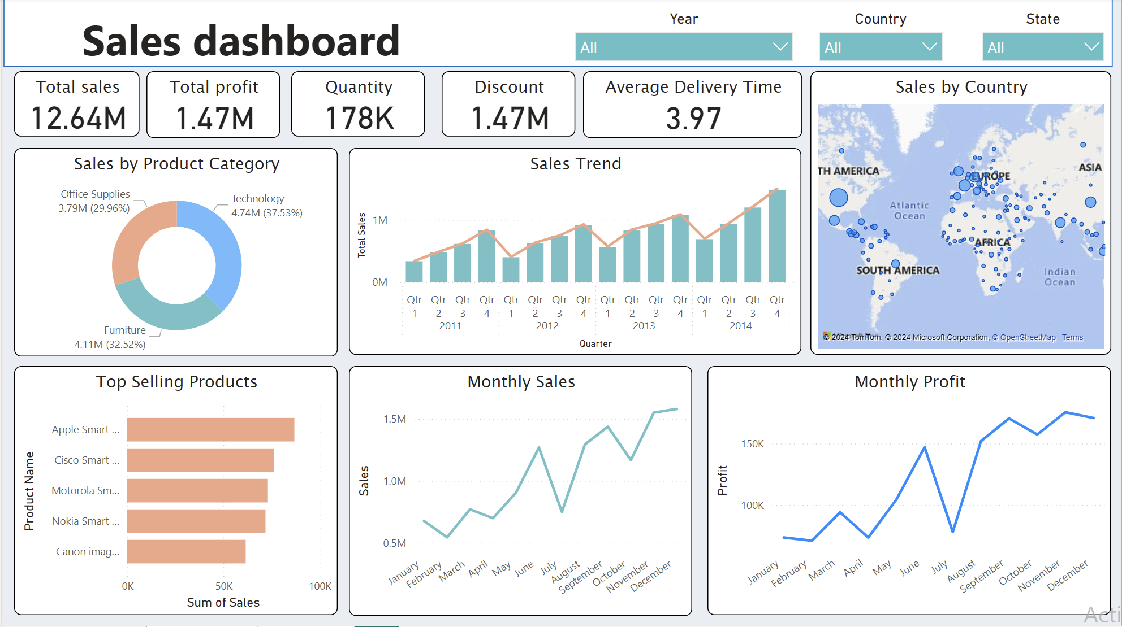

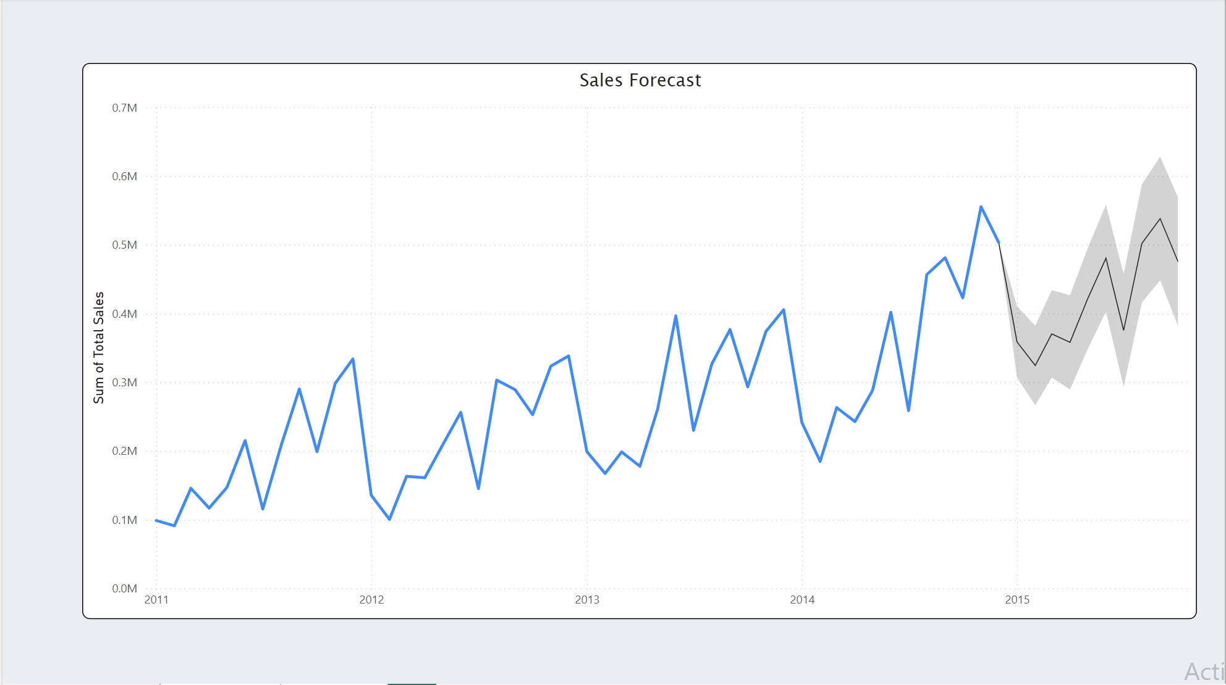

**Conclusion**

* By analysing sales trends, customer behaviour, and product performance through the visualizations and metrics presented, we aim to equip the sales, marketing, and operations teams with actionable insights. This analysis provides a foundation for optimizing sales strategies, identifying growth opportunities, and enhancing overall business profitability.
* The interactive dashboard, incorporating line charts with forecasts and dropdown filters, empowers users to delve deeper into the data and uncover hidden patterns. By leveraging these insights, the Global Superstore can make data-driven decisions to drive sales growth and customer satisfaction.